CripChat
An Australian Disability Podcast
CripChat is a weekly podcast produced and delivered by Australian Disability Limited, it aims to educate, entertain and inform the general community how they can help us create a more accessible and inclusive society for people with disabilities, their friends and family.
Who is involved
- Jonathan Shar
- David Daoud
- Ibby Dee
- Timothy Lachlan
Content Warning
This podcast may include content unsuitable for children who have not been exposed to people with disabilities related themes and issues that are sometimes expressed by using course language or politically incorrect terminology, these instances will occur rarely and only to demonstrate a point about how discrimination affects people with disabilities.
Topics
These are broad categories to help hosts select topics:
- Access
- Inclusion
- Fairness
- Equality
- A topic proposed by the audience and approved by hosts/board

Format

CripChat Possible Episodes + Spin-off Ideas
- Disability Friendships
- Disability and Inter-abled Relationships and Love
- Disability Representation in Media
- The Role of Social Media in Disability Advocacy

- Disability Rights: A Brief History of the Disability Rights Movement In Australia, UK And USA

  - The Origins of the Disability Rights Movement: a comparison situating Australia on the international stage.
  - Interviews with prominent figures in the disability rights space with their reflections about where we are now.
  - How social media and technology presents both a challenge and a chance for innovation in the Disability Rights field.
Disability Rights Activists of the past, present and future: a reflection on where our rights movement is now and where its going into the future.
- Disability Rights: Where we are now and how we hope the Disability Rights Movement will evolve in Australia
  - The Origins of the Disability Rights Movement: a comparison situating Australia on the international stage.
  - Interviews with prominent figures in the disability rights space with their reflections about where we are now.
  - How social media and technology presents both a challenge and a chance for innovation in the Disability Rights field and beyond.
  - Disability Rights Activists of the past, present and future: a reflection on where our rights movement is now and where its going into the future.
- Having a Disability with an associated Chronic Health Condition
- Living with a Rare Disability, nobody has even heard of except you, family and friends
- People with Disability, Our Values and Who Represents our wants and needs to People who can make Policy and Social Change.
- Person with a disability trapped in an ableist society
- DES/Job Active employment programs for people with disabilities good and bad experiences
No consensus on best day to post live videos. Best advice is to experiment and go off your own analytics.

Build Some Hype
Do this about a week before you plan on going live and then once again a few days before the event.
Post on personal profile and your business page announcing the fact that you will be going Live, what topic you will be covering, and the date and time.

Gauge Interest with Comment Ladders
This is where you post something and ask followers to comment if they are interested.
Simply post something like:
“Going Live on [day] at [time] to talk about [topic]! Who wants to tune-in? Comment “I’m in!” below.”
Then, wait for people to comment on your post and then add them to a list so you’re sure to follow up with them before you go Live.
Send Reminders
If your comment ladder was successful, you should have a list of people who are interested in watching your Live.
About an hour before you’re due to go Live, private message the people on your list to remind them that you’re going Live.

Organize Your Content

Write an Eye-Catching Title

Stick to 3-5 main talking points and not go over 45 minutes on camera

Optimize the Description concise and to the point.

Calls-to-actions “Say ‘Hi’ in the comments”, “Post a question below”

Make a point of welcoming people as they view the live video

Hold Q & A session at the end and promote it throughout the broad cast

Encourage Comments & Questions
Improve engagement on your videos by encouraging viewers to ask questions and drop comments on your Facebook Live.

Experiment with Interviews
Interviews are great because then you can share your content with two (or more) audiences.
You can also earn a bit of clout by interviewing an industry professional, positioning your brand as a great source of information in your niche.

Offer context constantly
“Hey, if you’re just joining us, welcome to our broadcast. We’re currently talking about [topic] and we’ve just covered [previous topic].”

When are our viewers online?
2:00am PST = 7:00pm AEST

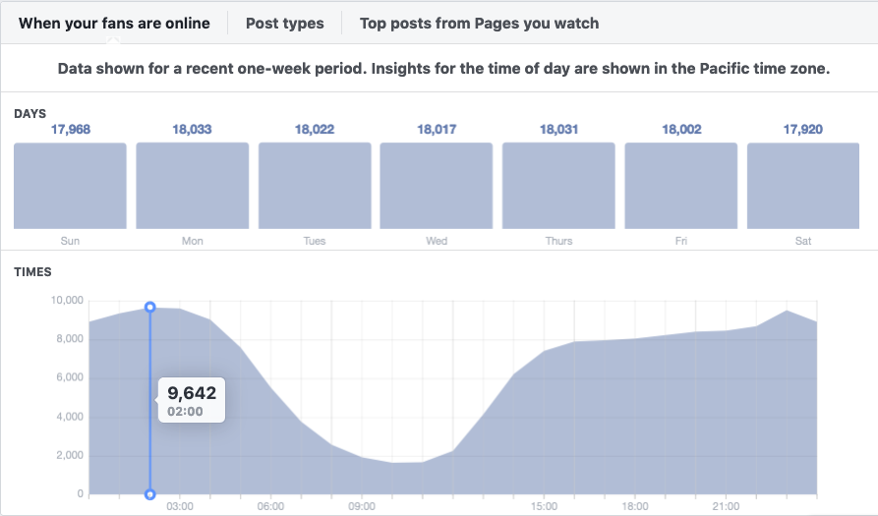

Sources

https://blog.sharelov.com/best-times-to-post-on-facebook/

https://www.searchenginejournal.com/facebook-live-best-practices/373495/#close

https://sproutsocial.com/insights/facebook-live-tips/

